**Screenshots of each year**

**2016**

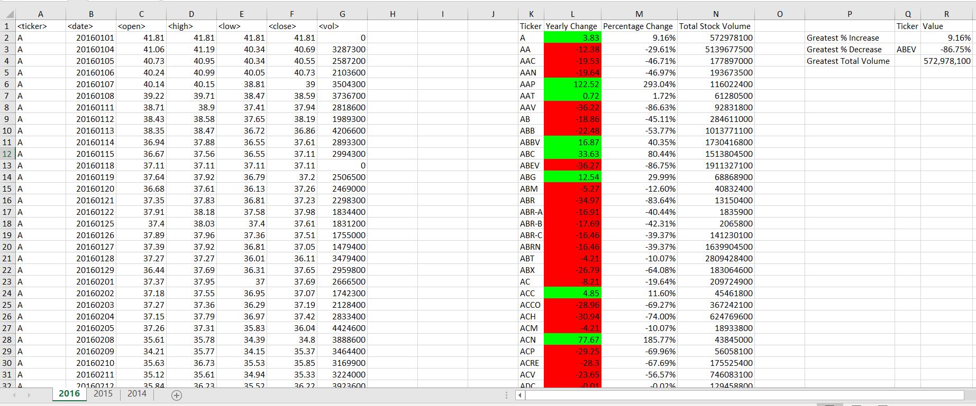

**2015**

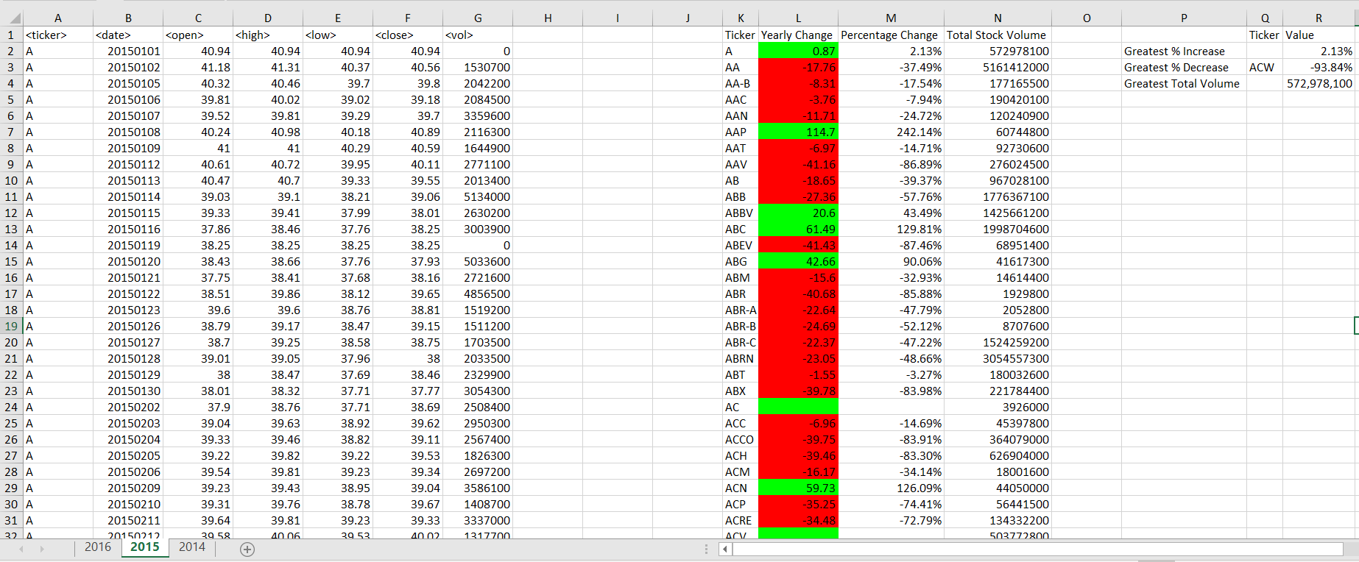

**2014**

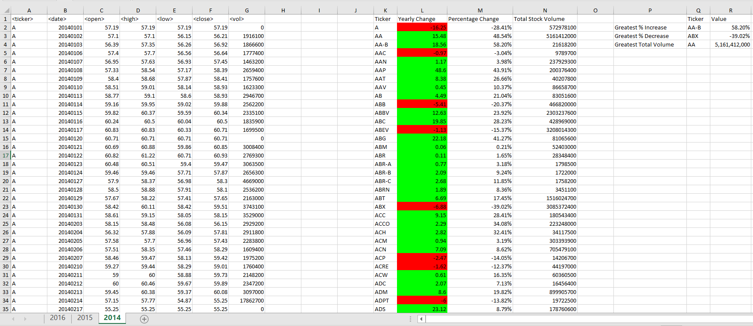

**VBA Script**

Sub StockAnalysis()

'Turn off screen update to make the code run faster

Application.ScreenUpdating = False

'Declare variables

Dim LastRow As Long

Dim Extracted_MMDD As String

Dim OpenPrice As Double

Dim ClosePrice As Double

'Loop through each WS in the WorkBook

For Each WS In Worksheets

'-----------------------------------------------------------------------------------------------------------------------

' TICKER SYMBOL - Loop though each row in column A and return all unique tickers

'-----------------------------------------------------------------------------------------------------------------------

'Create header for the Results Table

WS.Cells(1, 11).Value = "Ticker"

WS.Cells(1, 12).Value = "Yearly Change"

WS.Cells(1, 13).Value = "Percentage Change"

WS.Cells(1, 14).Value = "Total Stock Volume"

' Find Last Row for each sheet

LastRow = WS.Range("A" & Rows.Count).End(xlUp).Row

'Check in row in Raw Data Table

For i = 2 To LastRow

' Set Extracted_MMDD variable to hold the last 4 digits of the Date column

Extracted_MMDD = Right(Cells(i, 2).Value, 4)

' Check each row in Results Table. We still run to LastRow but use Exit For to exit loop when it's finished

For j = 2 To LastRow

' Loop to see if summary row iterator Ticker is the same as Raw Data row Ticker

If WS.Cells(j, 11).Value = WS.Cells(i, 1).Value Then

'-----------------------------------------------------------------------------------------------------------------------

' TOTAL VOLUME

'-----------------------------------------------------------------------------------------------------------------------

'then add the volumn to the overall volumn and then reassigning the total back to the cell

WS.Cells(j, 14).Value = WS.Cells(j, 14).Value + Cells(i, 7).Value

'------------------------------------------------------------------------------------------------------------------

'Yearly change from opening price at the beginning of a given year to the closing price at the

‘end of that year.

'------------------------------------------------------------------------------------------------------------------

'Grab Close Price on the last day of the year

If Extracted_MMDD = "1230" Or Extracted_MMDD = "1231" Then

ClosePrice = WS.Cells(i, 6).Value

'Get the difference between the Close Price and OpenPrice

WS.Cells(j, 12).Value = ClosePrice - OpenPrice

'% CHANGE

WS.Cells(j, 13).Value = (ClosePrice - OpenPrice) / OpenPrice

' Format %change column to Percentage format

WS.Cells(j, 13).NumberFormat = "0.00%"

End If

'exit for loop because we found the Ticker already existed

' *** this will only break the for loop with the j-iterator because it's the closest one, not both

‘ for-loops

Exit For

'if we iterate through and get to a Results row that is empty, this means we got to the end of

‘the Results row list

'and found no match for that Ticker, so we need to add the Ticker to the list

ElseIf WS.Cells(j, 11).Value = "" Then

'add the Ticker to the list

WS.Cells(j, 11).Value = WS.Cells(i, 1).Value

'add the first volumn value of that new ticker to the Results table

WS.Cells(j, 14).Value = WS.Cells(i, 7).Value

'------------------------------------------------------------------------------------------------------------------

'Yearly change from opening price at the beginning of a given year to the closing price at the

‘end of that year.

'------------------------------------------------------------------------------------------------------------------

'Grab the Open Price on the first day of the year

If Extracted_MMDD = "0101" Then

OpenPrice = WS.Cells(i, 3).Value

End If

'this exits the for loop so we don't go to to LastRow pointlessly

Exit For

End If

'------------------------------------------------------------------------------------------------------------------

'CONDITIONAL FORMATS

'------------------------------------------------------------------------------------------------------------------

If WS.Cells(j, 12).Value >= 0 Then

WS.Cells(j, 12).Interior.ColorIndex = 4

Else

WS.Cells(j, 12).Interior.ColorIndex = 3

End If

Next j

Next i

'---------------------------------------------------------------------------------------------------------------------------

'CHALLENGE: "Greatest % increase", "Greatest % decrease" and "Greatest total volume".

'---------------------------------------------------------------------------------------------------------------------------

'Add headers for the Challenge Table

WS.Cells(2, 16).Value = "Greatest % Increase"

WS.Cells(3, 16).Value = "Greatest % Decrease"

WS.Cells(4, 16).Value = "Greatest Total Volume"

WS.Cells(1, 17).Value = "Ticker"

WS.Cells(1, 18).Value = "Value"

'Find the last row of the Results Table

LastRow_Summary = WS.Range("K" & Rows.Count).End(xlUp).Row

'Set arbitrary values

MaxChange = WS.Cells(2, 13).Value

MinChange = WS.Cells(2, 13).Value

MaxVolume = WS.Cells(2, 14).Value

'Loop through each row in the Results Table

For j = 3 To LastRow_Summary

' Check if each value in the %Change column > Max change, then make it the Maxchange

If Cells(j, 13).Value > MaxChange Then

MaxChange = WS.Cells(j, 13).Value

WS.Cells(2, 17).Value = WS.Cells(j, 11).Value

' Check if each value in the %Change column < Mix change, then make it MinChange

ElseIf WS.Cells(j, 13).Value < MinChange Then

MinChange = WS.Cells(j, 13).Value

WS.Cells(3, 17).Value = WS.Cells(j, 11).Value

End If

' Find greatest volume

If Cells(j, 14).Value > MaxVolume Then

MaxVolume = WS.Cells(j, 14).Value

WS.Cells(4, 17).Value = WS.Cells(j, 11).Value

End If

Next j

‘ Format cells

WS.Cells(2, 18).Value = MaxChange

WS.Cells(2, 18).NumberFormat = "0.00%"

WS.Cells(3, 18).Value = MinChange

WS.Cells(3, 18).NumberFormat = "0.00%"

WS.Cells(4, 18).Value = MaxVolume

WS.Cells(4, 18).NumberFormat = "#,#00"

WS.Range("J1:S5").Columns.AutoFit

Next WS

End Sub